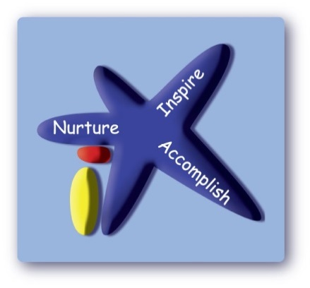
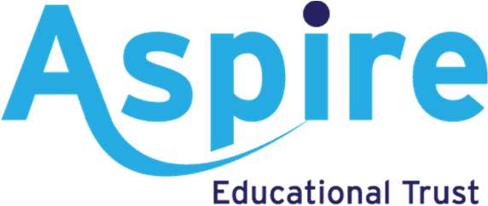

Victoria Road Primary School

PSHE Policy

Date policy last reviewed: | Sept 2022

Signed by:
Cathy Lord | Headteacher | Date: | Sept 2022
Andrew Cooper | Chair of governors | Date: | Sept 2022
Last updated: 12 August 2022

Contents:
Statement of intent
- [Updated] Legal framework
- Roles and responsibilities
- [Updated] Aims and structure of the PSHE curriculum
- [Updated] Safeguarding
- [Updated] Programme of study
- Assessment
- [Updated] Monitoring and review

Statement of intent
Victoria Rpad Primary School believes that a strong PSHE education is important to help our pupils develop into well-rounded members of society, who can make a positive contribution to their community.
The vision for pupils, staff and other members of the school community is to always look to achieve our personal best in every aspect of school life.

[Updated] Legal framework
[Updated] This policy has due regard to all relevant legislation and statutory guidance including, but not limited to, the following:
- Education Act 1996
- Education Act 2002
- Children and Social Work Act 2017
- DfE (2019) ‘Relationships Education, Relationships and Sex Education (RSE) and Health Education’
- [Updated] DfE (2022) ‘Keeping children safe in education 2022’ (KCSIE)
This policy operates in conjunction with the following school policies:
- [Primary schools only] Primary Relationships and Health Education Policy
- [Secondary schools only] Secondary Relationships, Sex and Health Education (RSHE) Policy
- Child Protection and Safeguarding Policy
- Complaints Procedures Policy

Roles and responsibilities
The governing board is responsible for:
- Ensuring the school’s PSHE Policy is implemented effectively.
- Ensuring that the PSHE Policy, as written, does not discriminate on any grounds or protected characteristics.
The headteacher is responsible for:
- Reviewing the PSHE Policy annually.
- Handling complaints regarding this policy, as outlined in the school’s Complaints Procedures Policy.
- Facilitating the day-to-day implementation and management of the PSHE Policy.
The PSHE coordinator is responsible for:
- Liaising with other staff and professional agencies to devise a suitable scheme of work ensuring comprehensive PSHE education.

[Updated] Aims and structure of the PSHE curriculum
Pupils will learn to do the following:
At Victoria Road we believe that the purpose of PSHE education is to develop in each child an understanding of their core values and how these will impact the decisions they make.
We want each child to develop their self-confidence and self-esteem, making the most of their abilities, through recognising their own worth. We want to prepare them to play an active role as citizens in a diverse society, working collaboratively with others, developing good relationships and respect the differences between members of the school and the wider community. We want each child to have the opportunity to make a positive contribution to the life of the school. Our children need to develop a healthy, safe lifestyle with the ability to make informed decisions. A key focus in our intent is for our children to recognise the importance of their own mental health and well-being.
We expect teachers to equip pupils with an age-appropriate, sound understanding of risk and with the knowledge and skills necessary to make safe and informed decisions.
Design
Whilst taking account of the content outlined in the National Curriculum, and in statutory guidance (on aspects including drug education, financial education, citizenship, personal safety, sex and relationship education (SRE) and the importance of physical activity and diet for a healthy lifestyle) we ensure that the delivered curriculum must reflect the needs of our pupils. Our PSHE curriculum is designed to support many of the principles of safeguarding and links closely to schools Safeguarding, SMSC and British Values. We are all aware of the important role the PSHE curriculum has in supporting school to implement the 9 protected characteristics of The Equality Act 2010.
[Updated] The school will use direct teaching via timetabled lessons to teach PSHE. Pupils will be taught PSHE through a range of teaching and learning styles, including active techniques such as discussion and group work. Pupils’ opinions and questions, unless inappropriate, will be responded to respectfully by teachers.
[Updated] PSHE lessons will be tailored to the pupils being taught, with consideration of:
- Pupils’ ability.
- Pupils’ age.
- [Updated] Pupils’ current knowledge on and readiness to learn about the topic being covered.
- Pupils’ cultural backgrounds.
- Pupils with EAL.
- Pupils with SEND or other needs.
To aid PSHE tailoring, the PSHE teacher will use discussions and other activities to ascertain pupils’ current knowledge and understanding of the subject being covered. The teaching programme will then be adjusted to reflect the composition of the class.
The school will deliver relationships and health education as part of its timetabled PSHE programme, with due regard to the school’s Primary Relationships and Health Education Policy.

[Updated] Safeguarding
[Updated] Due to the nature of the matters discussed in PSHE, there may be a higher likelihood for safeguarding concerns to arise or be disclosed by pupils. In line with the school’s Child Protection and Safeguarding Policy, all staff will be aware of the indicators and risks of a range of safeguarding issues, including child-on-child abuse, and will follow the appropriate procedures should a safeguarding concern be disclosed.
There is an element of PSHE in pastoral care, so the school will ensure that PSHE and pastoral care teams work together to help pupils feel comfortable indicating that they may be vulnerable and at risk.
[Updated] PSHE lessons will encourage pupils to discuss the issues raised in the lesson with a member of staff if they wish to do so. Pupils will also be made aware of how to raise concerns or make reports about potential safeguarding issues, and how reports will be handled. This also includes concerns and reports about a friend or peer.
[Updated] Where beneficial, the DSL or deputy DSL will be involved in the development of safeguarding-related elements of the PSHE curriculum

[Updated] Programme of study
[Updated] The PSHE programme of study will cover the following topics:
[New] Health and wellbeing
This topic will cover:
- Healthy lifestyles and physical wellbeing.
- Mental health.
- Ourselves, growing and changing.
- Keeping safe.
- Drugs, alcohol and tobacco.
[New] Relationships
This topic will cover:
- Families and close positive relationships.
- Friendships.
- Managing hurtful behaviour and bullying.
- Safe relationships.
- Respecting self and others.
[New] Living in the wider world
This topic will cover:
- Shared responsibilities.
- Communities.
- Media literacy and digital resilience.
- Economic wellbeing and money.
- Aspirations, work and careers.
- Social influences.

Assessment
The school will set the same high expectations of the quality of pupils’ work in PSHE as for other areas of the curriculum. A strong PSHE curriculum will be developed to build on knowledge pupils have previously acquired, including from other subjects, with regular feedback on their progress.
Lessons will be planned to ensure pupils of differing abilities are suitably challenged. Teaching will be assessed to identify where pupils need extra support or intervention.
Pupils’ knowledge and understanding will be assessed through formative assessment methods such as tests, written assignments, discussion groups and quizzes in order to monitor progress.

[Updated] Monitoring and review
[Updated] This policy will be reviewed by the headteacher and PSHE coordinator on an annual basis. Any changes to this policy will be communicated to all staff and other relevant parties.
The next scheduled review date for this policy is Autumn 2023

