Badminton Knowledge Organiser Year 5 & 6
End points to be assessed:
- Can I hold the racket correctly and hit a forehand shot?
- Can I produce a backhand serve?
- Can I show skill when manoeuvring around the court, using a chasse and split step?
- Can I discuss/show the difference between a drop and smash shot?
- Can I perform a rally with a partner?

Skills to be taught (Children will be taught to):
- To be able to grip a racket correctly; The hand holds the racket as if you’re shaking a persons hand. Be sure no to grip the racket tightly as this will make the wrist less flexible in rotating and flicking. Only the thumb, index and middle finger should be used to control the racket with the last 2 fingers resting comfortably on the badminton grip to balance the weight.
- How to hit a forehand shot
- To begin to understand how to serve using forehand and backhand (Backhand serve – Standing facing the net with dominant foot forward. Hold the shuttlecock by one feather tip, using index finger and thumb. Angle the shuttlecock so that it is facing your racket. The hitting action should be a gentle push, moving the racket gently backwards whilst releasing the shuttlecock, then moving gently forward to connect with the shuttlecock in a pushing action. After striking the push action should continue gently forward and up to continue momentum.)
- To effectively manoeuvre around the court to return a shot
- Demonstrate a split step and understand its use
- To start to perform different shots with accuracy E.g. drop shot and smash shot
- To start to understand the score system to badminton

Vocab
- Forehand – A type of shot where the hand moves across the body with the hand moving palm first.
- Backhand – The definition for a backhand means hitting the shuttle with your racket WHILE the back of your hand is facing the shuttle. This is a very unique shot in any racket sports. The technique to perform the badminton backhand is very different from tennis or squash.

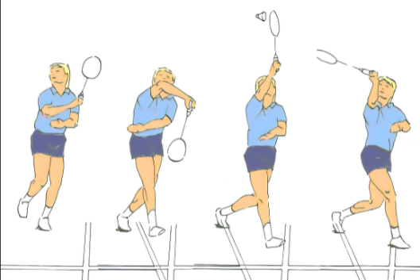

- Split step – It refers to a little jump which the player takes just before the opponent hits the shuttle and lands on the ground when the shuttle is hit by opponent. Learn the Split Step - Badminton Tutorial - YouTube
- Chasse (in to the net) – One foot leads while the other foot follows. The leading foot is always ahead.
- Smash – A smash shot in badminton is an offensive shot performed from the back part of the court. It has a downwards and straight trajectory, directed to the middle court of your opponent.
- Dropshot – The shuttlecock is hit so softly that it falls to the playing surface just after clearing the net.

